Honors Pre-Calc Rational Exponent Test Name: ____________________

Block: ________

In questions 1 – 4, rewrite the expression in radical or rational exponent form and then evaluate the expression.

1. 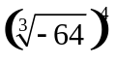 2. 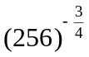

rational exponent form: _______ radical form: _______
answer: ____________________ answer: ____________________

In questions 3 – 6, simplify the expression.

3. 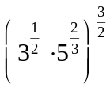 4. 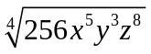

answer: ____________________ answer: ____________________

5. 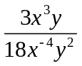 6. 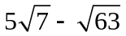

answer: ____________________ answer: ____________________

In questions 7 – 10, let f(x) = x - 2 and g(x) = x² + 1, perform the indicated operation and state the domain.
7. 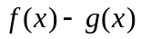 8. 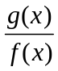

answer: ____________________ answer: ____________________
domain: __________ domain: __________

9. 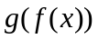 10. 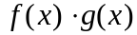

answer: ____________________ answer: ____________________
domain: __________ domain: __________

In question 11, verify if f and g are inverses.

11. f(x) = 2x – 6, g(x) = 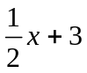

In questions 12 – 15, solve the equation. Check for extraneous solutions.

12. 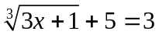 13. 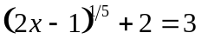

answer: __________ answer: ___________
14. 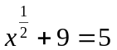 15. 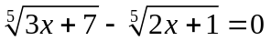

answer: __________ answer: ___________
In questions 16 – 17, find what is needed.
16. The volume of a cone can be found using the formula V = 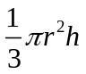 where r is the radius of the base, and h is the height. Find the length of the radius of a cone that has a volume of 46.9m³ and height of 12m. Round your radius to two decimal places.

radius = __________

17. The formula to convert Celsius, C, to Fahrenheit, F, is 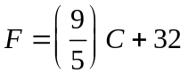. Write the inverse function. Use the inverse function to find the temperature in Celsius if it is 53° Fahrenheit. Round the temperature to two decimal places.

inverse: ____________________
Celsius = __________

